**Health & Safety Talk**

Toolbox Talk

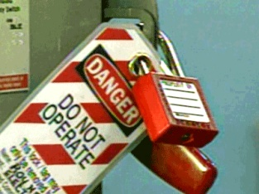 **Lock Out Tag Out**

Following Lock Out Tag Out procedures are essential to ensure no serious injuries occur within the workplace, particularly with plant and equipment.

Lock Out Tag Out applies to plant and equipment where the work to be carried out requires placing any part of the body in such a position that unexpected movements result in the release of stored energy, energizing of electrical systems or the flow of gases or fluids that could result in injury or death.

**What are the risks?**

Electrocution Amputation Death Serious Injury

Entrapment Property damage Significant cost to the business

**What should be done?**

There are many ways to ensure that hazardous energy sources are controlled when plant is being worked on. Some of these include:

* + Placing a danger tag
  + Placing a sign stating ‘do not operate’ on the machine or vehicle
  + Placing a lock out lock on switches (where possible)
  + Removing the plant / equipment key (where possible), and
  + Reporting to management immediately any faulty equipment

Never remove another persons lock/tag unless you have been authorised to do so by management and a thorough inspection of the plant and equipment has occurred.

**Who is responsible?**

Lock Out Tag Out procedures need to be applied when plant/machinery is being worked on. All staff and management are responsible and must ensure Locks Out Tag Out procedures are being followed correctly.

|  |  |
| --- | --- |
| **Consultation** |  |

**Date of Meeting:**_____________________

**Attendees** (list attendees present)

|  |
| --- |
|  |

**Items Discussed**

|  |
| --- |
|  |

**Action Items**

|  |
| --- |
|  |

**Management Sign Off**

**Name:** _______________________________________

**Sign:** ___________________________________ **Date:** ______________________________